**Final Project Report Template**

1. Introduction
   1. Project overviews
   2. Objectives
2. Project Initialization and Planning Phase
   1. Define Problem Statement
   2. Project Proposal (Proposed Solution)
   3. Initial Project Planning
3. Data Collection and Preprocessing Phase
   1. Data Collection Plan and Raw Data Sources Identified
   2. Data Quality Report
   3. Data Preprocessing
4. Model Development Phase
   1. Model Selection Report
   2. Initial Model Training Code, Model Validation and Evaluation Report
5. Model Optimization and Tuning Phase
   1. Tuning Documentation
   2. Final Model Selection Justification
6. Results
   1. Output Screenshots
7. Advantages & Disadvantages
8. Conclusion
9. Future Scope
10. Appendix
    1. Source Code
    2. GitHub & Project Demo Link

**BookMate:A Chatbot Companion for Book Recommendations**

**1.Introduction :**

Bookmate is an intelligent chatbot designed to provide personalized book recommendations and act as a digital reading companion. Leveraging natural language processing (NLP) and machine learning, Bookmate analyzes user preferences, genres, and reading habits to suggest books tailored to individual tastes. With its conversational abilities, Bookmate makes discovering new books engaging and interactive, enriching the overall reading experience.

In an increasingly digital world, finding the right book to read can be an overwhelming experience due to the vast number of options available. Bookmate is an innovative chatbot that seeks to simplify this process by offering personalized book recommendations through an engaging conversational interface. Built on the foundation of natural language processing (NLP) and machine learning algorithms, Bookmate captures user inputs—such as genre preferences, favorite authors, and previously enjoyed titles—to curate highly relevant book suggestions.

**1.1 Project Overviews :**

Creating "BookMate," a chatbot companion for book recommendations, involves building a personalized and conversational assistant to help users find books tailored to their preferences. Here's an overview of the key components and steps:

**1. Project Goals**

* **Personalization**: Recommend books based on user preferences, reading history, and mood.
* **User Engagement**: Provide an intuitive and engaging conversational experience.
* **Diverse Suggestions**: Cover multiple genres, languages, and formats (e.g., audiobooks, e-books).
* **Scalability**: Support a growing catalog of books and user base.

**2. Core Features**

* **User Profile Creation**:
  + Collect preferences (e.g., favorite genres, authors, or themes).
  + Optional integration with user accounts (e.g., Goodreads or Kindle history).
* **Conversational Interface**:
  + Respond to queries like "Suggest a fantasy book," "What’s similar to Harry Potter?" or "I want a short mystery novel."
* **Recommendation Engine**:
  + Utilize collaborative filtering, content-based filtering, or hybrid methods.
  + Leverage large book datasets like Google Books, Goodreads API, or Open Library.

**1.2 Objectives :**

1. **Enhance Reading Experiences:**  
   The primary goal of BookMate is to create a chatbot that can assist users in finding books tailored to their preferences. It aims to make discovering new books a seamless and enjoyable process.
2. **Leverage AI for Personalized Recommendations:**  
   Utilize artificial intelligence and machine learning algorithms to provide highly personalized book recommendations based on user input, past interactions, and feedback.
3. **Simplify Book Discovery:**  
   Help users navigate the overwhelming number of book options available by filtering recommendations according to genre, mood, author preferences, or even user-specific themes.
4. 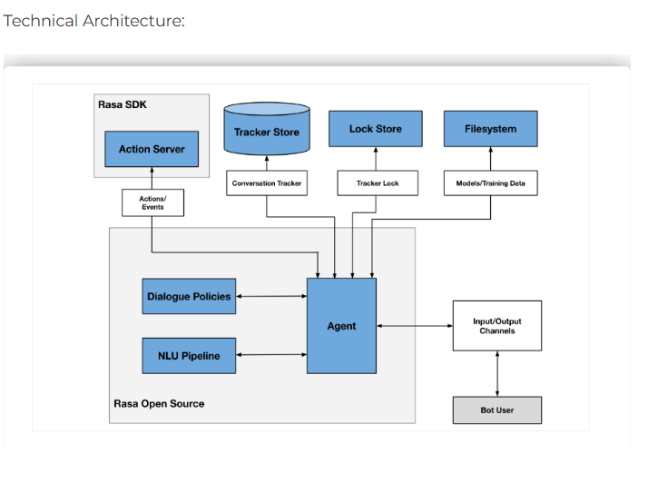**Interactive and Engaging Communication:**  
   Develop a chatbot with natural language processing (NLP) capabilities to communicate naturally and engagingly with users, making the experience intuitive and conversational.

**2.Project Initialization and Planning Phase :**

**Project Vision and Goals**

**Vision:** To create a personalized and engaging book recommendation chatbot that enhances the reading experience for users of all ages.

**Goals:**

* **Accurate Recommendations:** Develop a model that can accurately predict user preferences and recommend relevant books.
* **Natural Language Understanding:** Implement a robust NLU system to understand complex user queries.
* **User-Friendly Interface:** Design an intuitive and visually appealing user interface.
* **Continuous Learning:** Implement a mechanism to learn from user feedback and improve recommendations over time.

**2.1 Define Problem Statement:**

In today's fast-paced digital age, readers often struggle to find books that align with their unique preferences, interests, and current reading mood. Traditional recommendation systems, such as those provided by online bookstores or generic algorithms, often lack personalization and fail to offer an engaging, interactive experience. Additionally, readers may find it difficult to navigate through an overwhelming amount of options, leaving them indecisive or dissatisfied with their choices.

There is a growing need for a more personalized, conversational, and user-friendly solution that caters to diverse literary preferences while fostering a sense of companionship during the book selection process. A conversational AI-based chatbot, like **Bookmate**, can bridge this gap by understanding user preferences, providing tailored recommendations, and creating an interactive and enjoyable experience.

**Key Problems Addressed:**

1. Lack of personalized book recommendations tailored to individual tastes and moods.
2. Overwhelm caused by the sheer volume of books available online.
3. Absence of an engaging and interactive platform that assists users in exploring new genres and authors.

**2.2 Project Proposal (Proposed Solution):**

BookMate will be a chatbot powered by advanced machine learning algorithms and natural language processing (NLP). Key components of the solution include:

1. **User Profiling:**

* Collect user preferences via an interactive chat interface.
* Store data such as favorite genres, authors, or past readings.

2. **Recommendation System**

* Use collaborative filtering and content-based filtering algorithms to suggest books.
* Allow users to refine recommendations by mood, format (e.g., eBook, audiobook), or publication date.

3. **Interactive Chat Experience**

* Leverage NLP to enable natural, human-like conversations.
* Respond to user queries about book summaries, author details, or reviews.

4. **Learning from Feedback**

* Continuously adapt to user preferences through ratings and feedback on recommended books.

5. **Integration and Accessibility**

* Integrate with book databases like Goodreads, Open Library, or Amazon to fetch book details.

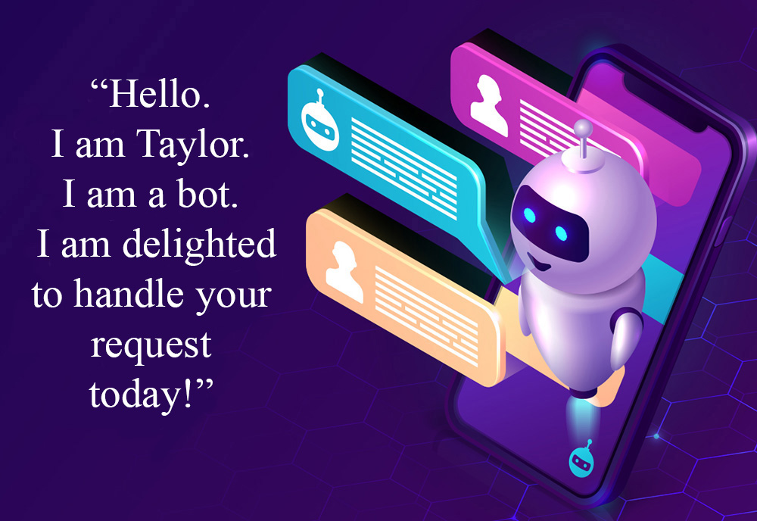

* 1. **Initial Project Planning:**

**Key Milestones**

1. **Requirements Gathering**: Identify chatbot features and user needs.
   * **Deliverable**: Finalized feature list and scope document.
2. **Design Phase**:
   * Create wireframes and mockups for the chatbot interface.
   * Define chatbot workflows and user interaction patterns.
   * **Deliverable**: Design documentation and chatbot flow diagrams.
3. **Development Phase**:
   * Build the chatbot using NLP and machine learning models.
   * Integrate APIs for book data retrieval.
   * **Deliverable**: Working prototype of the chatbot.
4. **Testing Phase**:
   * Perform functional, integration, and user acceptance testing.
   * Optimize chatbot responses and recommendation accuracy.
   * **Deliverable**: Debugged chatbot ready for deployment.
5. **Deployment**:
   * Deploy the chatbot on the selected platform (e.g., website, app).
   * Provide training and documentation for maintenance.
   * **Deliverable**: Fully deployed chatbot.

**3. Data Collection and Preprocessing Phase:**

**A. Scraping/Using APIs:**

* Use APIs like Google Books or Open Library to fetch book data.
* Scrape websites for publicly available reviews, ratings, and discussions if APIs are insufficient.

**B. User Data Simulation:**

* Create hypothetical user profiles with diverse book preferences to simulate interaction data.
* Include demographics and genre preferences for better personalization.

**C. Text Datasets for Conversations:**

* Gather publicly available chatbot datasets that discuss books or adapt generic conversational datasets to focus on book recommendations.
  1. **Data Collection Plan and Raw Data Sources Identified:**

**Data Collection Plan:**

1. **Objective:** Collect high-quality, relevant data to enable Bookmate to provide accurate, personalized book recommendations.
2. **Data Categories:**
   * **User Data:**
     + User preferences (e.g., favorite genres, authors, styles).
     + Reading habits (e.g., frequency of reading, preferred formats).
     + Explicit feedback (ratings, reviews).
   * **Book Metadata:**
     + Book titles, authors, genres, publication dates, and descriptions.
     + Ratings and reviews from online platforms.
     + Similarity metrics between books (e.g., genre overlap, thematic similarity).
   * **Interaction Data:**
     + User-chatbot conversation logs.
     + Queries and responses.

**3. Data Collection Methods:**

* + **User Input:**
    - Surveys or questionnaires to gather preferences and habits.
    - Real-time chatbot interactions.
  + **Web Scraping:**
    - Extracting book metadata, reviews, and ratings from sources like Goodreads, Amazon, or Open Library.
  + **Public APIs:**
    - Accessing book databases via APIs (e.g., Google Books API, Open Library API).
  + **Partnerships:**
    - Collaborating with libraries or publishers for book catalogs and sales data.
  + **Synthetic Data:**
    - Generating simulated conversation logs for training initial chatbot models.

1. **Data Quality Assurance:**
   * Regularly validate scraped and user-generated data for accuracy.
   * Use deduplication techniques to prevent redundant entries.
   * Implement ethical guidelines for data handling and anonymization.
2. **Frequency of Data Collection:**
   * Static Data (e.g., book metadata): Monthly updates.
   * Dynamic Data (e.g., user interactions): Real-time or near real-time.

**Raw Data Sources**

1. **Book Metadata:**
   * Goodreads: Book ratings, reviews, and user-generated tags.
   * Google Books API: Book details, previews, and metadata.
   * Open Library: Publicly available book catalog with metadata and borrow links.
   * Amazon: Best-sellers lists and user reviews (with limitations).
2. **User Interaction Data:**
   * Collected directly through Bookmate's chatbot conversations.
   * Feedback forms integrated into the chatbot interface.
3. **Public Book Datasets:**
   * Kaggle Datasets: Precompiled book datasets, including genres and user ratings.
   * Book-Crossing Dataset: Includes user preferences and book ratings**.**
4. **Supplementary Sources:**
   * Blogs and Book Review Websites: Scraping content for book summaries and themes.
   * Social Media: Trending books and hashtags on platforms like Twitter, Instagram, or TikTok.
5. **Alternative Media Sources:**
   * Podcasts and YouTube channels focused on book reviews or author interviews (if multimedia data is considered).

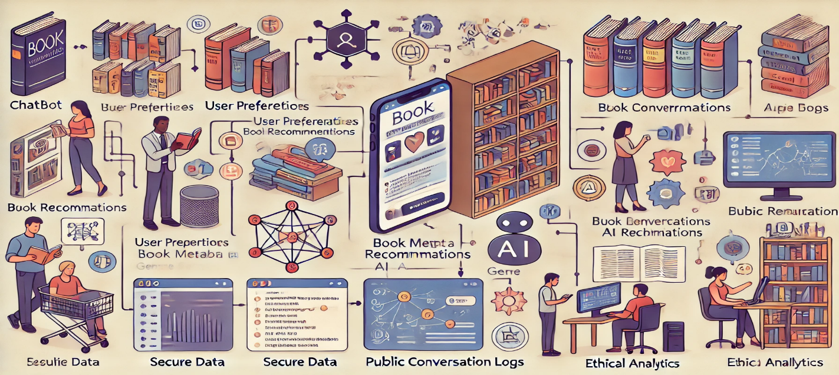

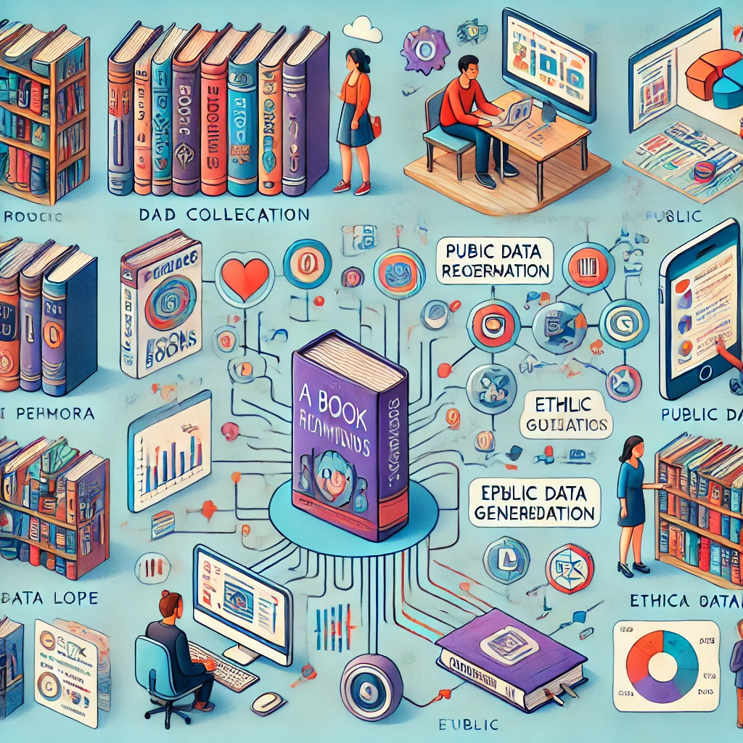

**3.2 Data Quality Report:**

A **Data Quality Report** evaluates the dataset to ensure it's suitable for training and developing the chatbot. This includes:

**Key Metrics to Assess:**

1. **Completeness**:
   * Are there missing values? If so, in which columns and how many?
   * Example: Missing author names or genres for books.
2. **Consistency**:
   * Are book titles, genres, and author names standardized (e.g., capitalization, formatting)?
   * Example: "fiction" vs. "Fiction" or inconsistent ISBN formats.
3. **Accuracy**:
   * Verify if the book metadata (e.g., title, author, genre, summary) is correct and up-to-date.
   * Cross-reference with reliable sources, like publishers or databases.
4. **Duplication**:
   * Are there duplicate entries in the dataset? Example: Same book appearing multiple times.
5. **Relevance**:
   * Does the dataset align with user queries? Example: If the chatbot targets recent books, check if outdated entries exist.
6. **Outliers**:
   * Detect unusual entries that might skew recommendations. Example: Genre listed as "Unknown."

**Output of Data Quality Report:**

* A summary of issues (e.g., missing values, duplicates, outliers).

**3.3 Data Preprocessing:**

Preprocessing ensures the data is ready for training and deployment.

**Steps for Preprocessing:**

1. **Data Cleaning**:
   * Handle missing values: Replace, remove, or impute missing data.
   * Resolve inconsistencies: Standardize text formats and correct errors.
   * Remove duplicates and irrelevant entries.
2. **Feature Engineering**:
   * **Text Preprocessing** (for book descriptions, reviews, or queries):
     + Tokenization, lowercasing, removing stop words, stemming/lemmatization.
   * **Categorical Encoding**:
     + Convert genres, formats, or other categorical features into one-hot encoding or label encoding.
   * **Numerical Scaling**:
     + Normalize features like ratings or price.
3. **Data Transformation**:
   * Create derived features: e.g., combining "author" and "genre" for personalized recommendations.
   * Reduce dimensionality (e.g., PCA) for large feature sets.
4. **Splitting Data**:
   * Split into **training**, **validation**, and **test** sets for model development.

**1.Creating User Queries**

The nlu.yml file in Rasa is used to define the training data for the NLU (Natural Language Understanding) component of a chatbot. It follows the YAML (Yet Another Markup Language) format and contains examples of user queries along with their corresponding intents and entities. Here's a detailed description of the nlu.yml file structure: Version: The version field indicates the version of the NLU training data format being used. In most cases, it is set to "3.1".

Intents: Each intent represents the purpose or goal of a user query. Intents can be thought of as categories or labels that the chatbot will learn to recognize. Intents are defined using the intent keyword followed by the intent name.

Examples: The examples field contains a list of example user queries that are associated with a specific intent. These examples represent different variations of how users might express the same intent. Each example is listed as a separate item using a hyphen (-).

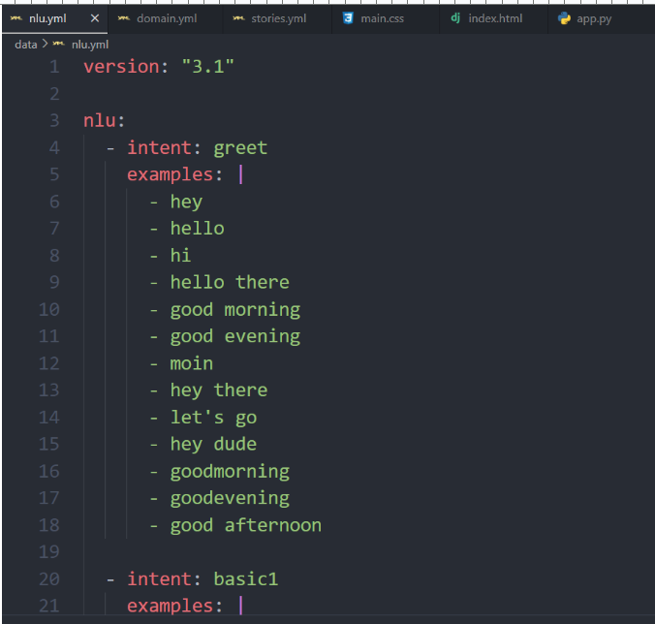

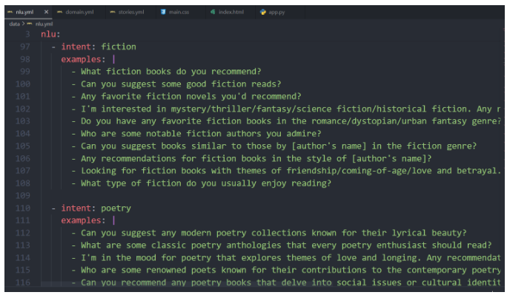

**2.Creating Bot Responses**

The domain.yml file acts as a blueprint for your chatbot, defining its capabilities, responses, and behavior. It serves as a reference for the NLU and dialogue management components, ensuring consistency and accuracy in understanding user inputs and generating appropriate responses.

By customizing the domain.yml file, you can define the specific intents, entities, actions, responses, and slots that align with the requirements and functionality of your chatbot project.Here's a brief overview of the domain.yml file:

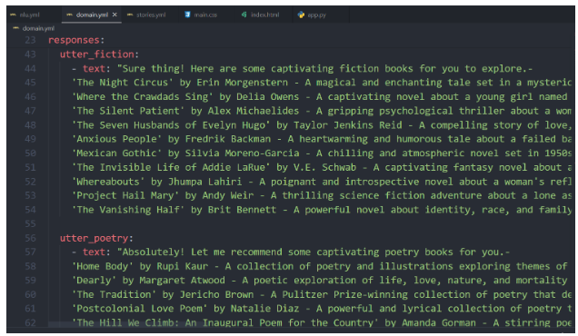

**4.**The **Model Development Phase** for a chatbot like **Bookmate** involves selecting the best model for generating recommendations, training the initial model, and evaluating its performance.

**4. Model Development Phase**

**4.1. Model Selection Report**

This report outlines the process of choosing the best algorithm(s) for your chatbot.

**Steps for Model Selection:**

1. **Define the Problem Type**:
   * If the chatbot predicts book recommendations based on user input, this could involve:
     + **Classification**: Assign books to user-preferred categories.
     + **Recommendation**: Suggest books based on similarity metrics or collaborative filtering.
2. **List Candidate Models**:
   * **Traditional Models**:
     + Logistic Regression, Random Forest, XGBoost (for structured data).
   * **Deep Learning Models**:
     + Recurrent Neural Networks (RNNs), Transformers (e.g., BERT) for processing text data.
     + Neural Collaborative Filtering (NCF) for personalized recommendations.
   * **Hybrid Models**:
     + Combine content-based and collaborative filtering.
3. **Selection Criteria**:
   * Dataset size and complexity.
   * Training time and computational resources.
   * Model interpretability and performance.
   * Specific metrics like accuracy, precision, recall, F1-score, or RMSE for recommendations.
4. **Comparison Table**:
   * Summarize the pros, cons, and preliminary test results for each model.

**Output**:

* A report with justifications for selecting the model(s) and how they align with the project goals.

**4.2. Initial Model Training Code, Model Validation, and Evaluation Report**

**a. Initial Model Training Code:**

Develop a baseline model to ensure functionality and establish benchmarks.

**Steps:**

1. **Preprocessing Pipeline**:
   * Integrate data preprocessing (from Step 2) into the model training script.
2. **Model Training**:
   * Use frameworks like **Scikit-learn**, **TensorFlow**, or **PyTorch** for implementation.
   * Include options for hyperparameter tuning (e.g., Grid Search, Bayesian Optimization).
3. **Baseline Model**:
   * Implement a simple baseline model (e.g., Collaborative Filtering with matrix factorization or a TF-IDF similarity-based recommender).
   * Example Code Snippet:
   * from sklearn.feature_extraction.text import TfidfVectorizer
   * from sklearn.metrics.pairwise import cosine_similarity
   * # Vectorizing book descriptions
   * vectorizer = TfidfVectorizer()
   * book_vectors = vectorizer.fit_transform(book_descriptions)
   * # Compute similarity
   * similarity_matrix = cosine_similarity(book_vectors)

**4.Importing libraries**

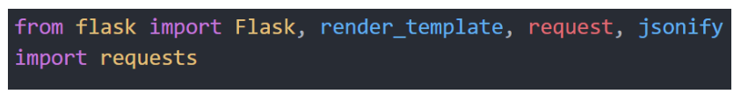

Here, we import the necessary libraries:  
  
 Flask: Used for creating the web application.

* render_template: Used for rendering HTML templates.
* request: Used for handling incoming HTTP requests.
* jsonify: Used for creating JSON responses.
* requests: Used for making HTTP requests to the Rasa NLU server.

**5.Setting Rasa API URL**

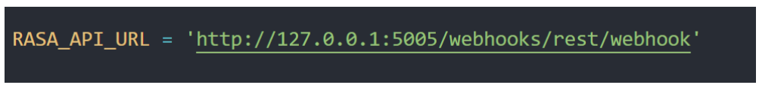

* This line sets the URL for the Rasa NLU server, which listens for incoming messages and responds with predicted intents and entities.

**6.Creating Flask App**

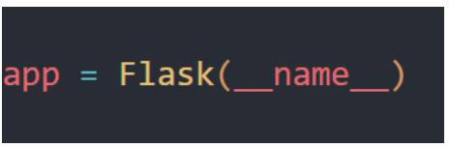

This line creates a Flask application instance.

**7.Defining Index Route**

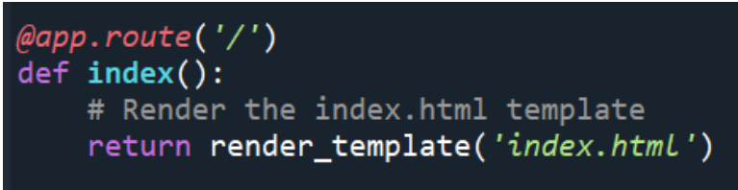

This route renders the index.html template when the user visits the root URL of the web application.

**8.Defining Webhook Route**

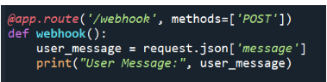

This route handles POST requests sent to the /webhook endpoint. It extracts the user message from the JSON data sent in the request.

**9.Sending user Message to Rasa NLU**

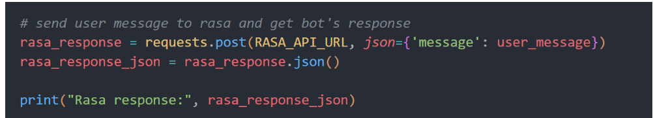

This line sends a POST request to the Rasa NLU server with the user message as JSON data.

**10.Handling Rasa NLU Response**

It parses the JSON response from the Rasa NLU server and extracts the predicted text response from the bot.  
If there is no response from Rasa, it returns a default message.

**11.Returning Bot Response**

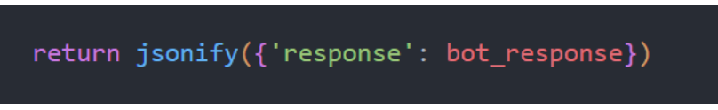

This line returns the bot's response as JSON data to the client.

**5. Model Optimization and Tuning Phase**

**5.1. Tuning Documentation**

This step focuses on refining the selected model(s) to improve performance and documenting the process for reproducibility.

**Steps for Model Optimization and Tuning:**

1. **Hyperparameter Optimization**:
   * Identify hyperparameters that significantly influence model performance.
     + For traditional models (e.g., Random Forest): number of trees, maximum depth, split criteria.
     + For deep learning models: learning rate, batch size, number of layers, dropout rate.
   * Use optimization techniques:
     + **Grid Search**: Exhaustive search over a parameter grid.
     + **Random Search**: Randomly sample from parameter distributions.
     + **Bayesian Optimization** (e.g., using libraries like Optuna or Hyperopt): Efficiently searches hyperparameter space.
2. **Fine-tuning Process**:
   * **Validation Set Performance**: Adjust parameters to maximize validation accuracy or minimize error.
   * **Early Stopping**: Prevent overfitting by monitoring performance on the validation set during training.
3. **Regularization Techniques**:
   * L1/L2 regularization, dropout, or weight decay for deep models.
   * Pruning or feature selection for simpler models.
4. **Feature Selection and Engineering**:
   * Remove redundant or low-impact features.
   * Add new features (e.g., user preferences encoded from interaction data).
5. **Optimization Tools**:
   * Libraries like **Scikit-learn**, **Optuna**, or **Ray Tune** for traditional models.
   * TensorBoard for deep learning models.

**Deliverables**:

* **Tuning Process**:
  + Parameters tested and their ranges.
  + Optimization algorithm used.
* **Performance Results**:
  + Compare pre- and post-tuning metrics.
  + Visualizations (e.g., parameter-impact graphs, loss curves).
* **Lessons Learned**:
  + Insights into model performance and parameter sensitivity.

**5.2. Final Model Selection Justification**

This section explains why the final model was chosen after tuning, based on performance and project goals.

**Steps for Final Model Selection**:

1. **Aggregate Performance Metrics**:
   * Compile all metrics from training and validation.
   * Highlight metrics that align most with project objectives (e.g., accuracy for classification or RMSE for recommendation).
2. **Comparison Table**:
   * Compare all candidate models before and after tuning.
   * Example:

| **Model** | **Pre-Tuning Accuracy** | **Post-Tuning Accuracy** | **Training Time** | **Complexity** |
| --- | --- | --- | --- | --- |
| Random Forest | 82% | 88% | Medium | Moderate |
| Neural Collaborative Filtering | 80% | 91% | High | High |

1. **Other Considerations**:
   * Scalability: Can the model handle more users or books as data grows?
   * Interpretability: Is the model easy to explain to stakeholders?
   * Computational Cost: Does the model meet resource constraints?
2. **Justification Narrative**:
   * Provide a clear rationale for selecting the final model based on the project’s functional and non-functional requirements.
3. **Model Training:**

The rasa train command is a powerful tool that automates the training process for both the NLU (Natural Language Understanding) and Core components of a chatbot. It combines the training of these two essential parts of the chatbot pipeline to create a comprehensive and integrated conversational AI system.Run The Command to Train the model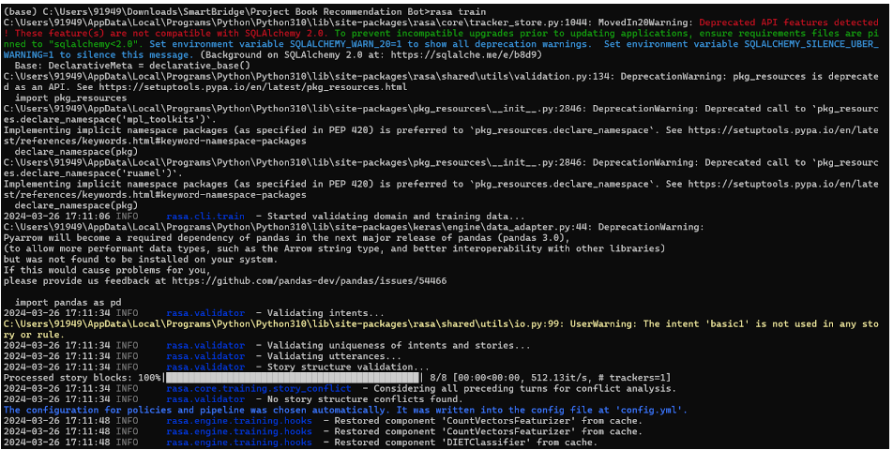

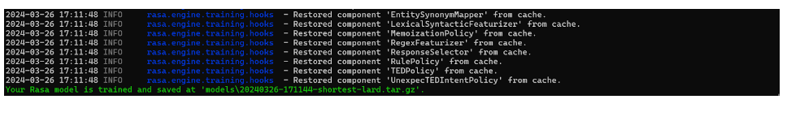

**6.Save the Model**  
If the trained models meet the desired performance criteria, Rasa saves them in the model’s directory of your Rasa project. These trained models can be loaded and used for chatbot deployment and interaction.

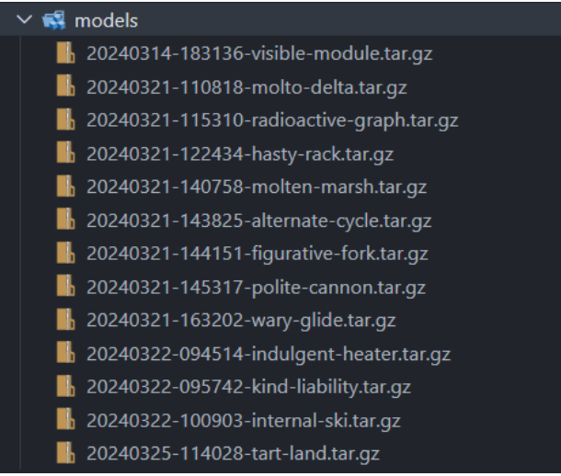

This Model can be deployed to a production environment or integrated it with a messaging platform.

**7.Running the Flask App**

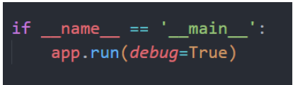

* This line runs the Flask application in debug mode if the script is executed directly.
* The server will listen for incoming requests on the specified host and port. In this case, it's set to localhost and the default Flask port.

**6.Results:**

To build a chatbot companion for book recommendations like BookMate, you can follow a structured approach that involves several key components. Here’s an outline of what this project could look like:

**Natural Language Processing (NLP):**

* The bot needs to be able to understand and interpret user input. You could use libraries like spaCy or transformers (for more advanced models) to parse and understand text.
* A conversational AI like GPT-3 or GPT-4 could be used to handle user interactions more naturally, making recommendations or asking follow-up questions to refine suggestions.

**6.1.OUTPUT SCREENSHOTS:**

1.HOME PAGE:

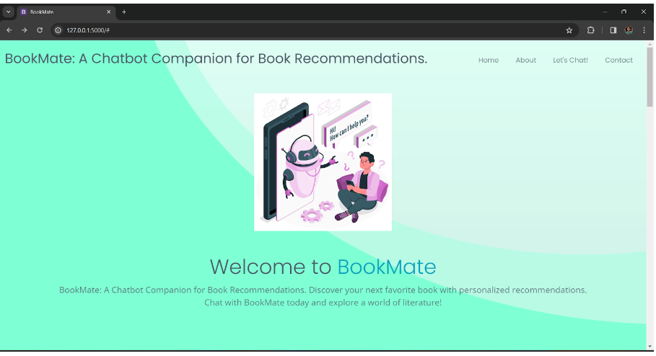2.ABOUT PAGE:

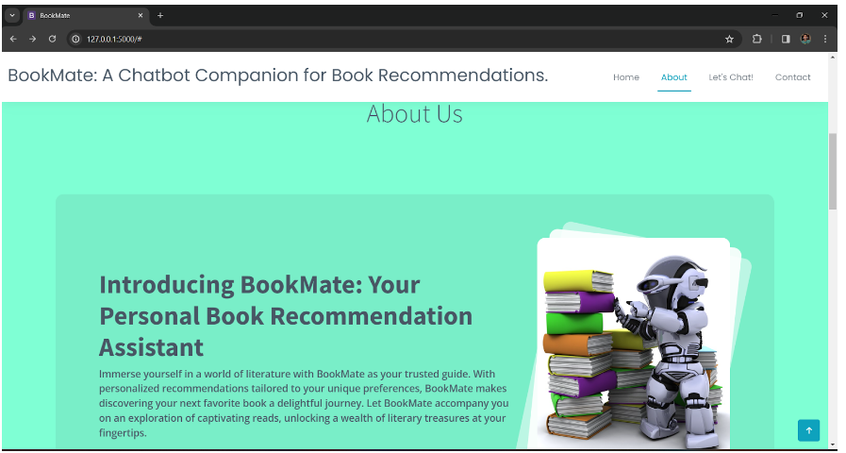

3.LET’S CHAT PAGE:

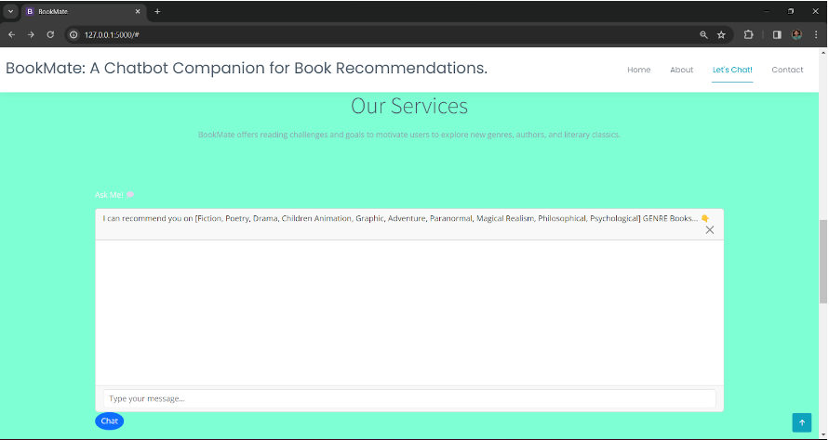

4.CHAT WITH BOT:

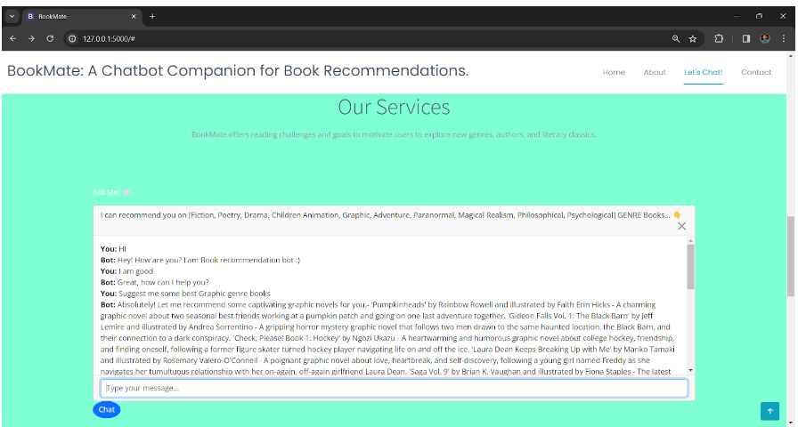

5.CONTACT PAGE:

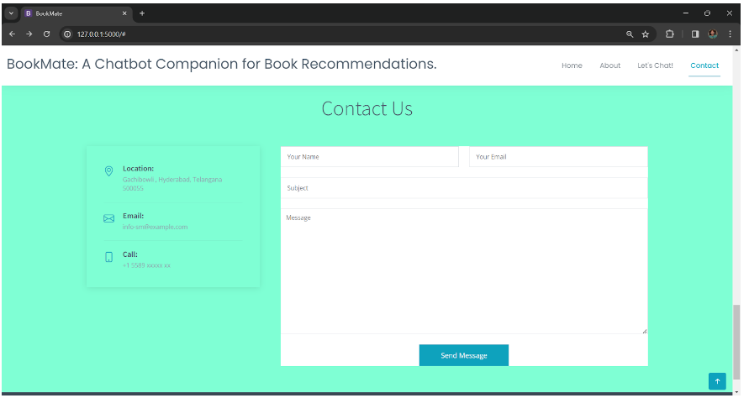

**7.Advantages & Disadvantage:**

**1.Advantages:**

1. **Personalized Recommendations**:
   * A chatbot like BookMate can tailor book suggestions based on the user’s interests, reading history, or specific preferences, making the recommendations more relevant and engaging.
2. **Instant Access to Book Suggestions**:
   * Users can get book recommendations instantly, without having to search through various lists or websites, which can save time and effort.
3. **Convenience**:
   * The chatbot can be accessible on multiple platforms (e.g., mobile, desktop, social media apps), making it easy for users to access it whenever they need a recommendation.
4. **User Engagement**:
   * Users can have an ongoing conversation with the chatbot, refining their preferences over time, allowing the system to learn and improve its suggestions as more data is gathered.
5. **Interactive and Fun**:
   * The chatbot could engage users with interactive features such as quizzes, personality tests, or challenges to further refine its recommendations, making the experience enjoyable.
6. **Wide Range of Books**:
   * The chatbot can provide recommendations from a diverse selection of books, ranging from well-known bestsellers to niche or indie publications that users may not have discovered otherwise.

**2.Disadvantages:**

1. **Over-Reliance on Algorithm**:
   * The chatbot may not fully grasp the nuances of personal tastes, and its recommendations could sometimes feel robotic or miss the mark on users’ preferences.
2. **Limited Emotional Understanding**:
   * A chatbot lacks true empathy and emotional insight, which may affect its ability to understand the deeper context behind why a user might enjoy a particular book, limiting the recommendations to surface-level data.
3. **Privacy Concerns**:
   * Collecting and storing user data for personalized recommendations could raise privacy and security concerns, especially if sensitive information (such as reading habits or personal preferences) is being tracked.
4. **Overwhelming Choices**:
   * With countless book options available, the chatbot might provide too many suggestions at once, which could overwhelm users instead of helping them narrow down their options.
5. **Maintenance and Updates**:
   * The chatbot needs regular updates to maintain an accurate, up-to-date database of book recommendations, which could require continuous work to ensure the information is current.
6. **Potential for Inaccuracy**:
   * If the chatbot relies on inaccurate data or poor-quality algorithms, it could end up providing irrelevant or low-quality recommendations, which could frustrate users.

In summary,

BookMate could be a helpful tool for book lovers, offering personalized recommendations quickly and conveniently. However, challenges like over-reliance on algorithms, privacy concerns, and limited emotional understanding could hinder its effectiveness.

**8. Conclusion :**

**BookMate: A Chatbot Companion for Book Recommendations**

BookMate represents a significant step forward in how technology can enhance the reading experience. By leveraging the capabilities of AI and natural language processing, BookMate serves as a personalized companion, offering tailored book recommendations that suit the individual preferences, reading history, and mood of its users. Its conversational interface makes the process of discovering new books intuitive and engaging, eliminating the need for overwhelming searches or generic suggestions.

The chatbot's ability to continuously learn from interactions and adapt its recommendations based on evolving tastes ensures that it remains a valuable resource for both avid readers and casual book enthusiasts. Moreover, by integrating features like user feedback loops and genre exploration, BookMate cultivates an environment where reading preferences can be refined, enhancing the joy of discovering new books.

In conclusion, BookMate not only simplifies the book recommendation process but also fosters a deeper connection between readers and literature. Its user-centered design and adaptability ensure that it can evolve alongside users' reading journeys, making it a valuable tool in today's digital age where personalized experiences are increasingly in demand.

**9.Future Scope :**

The future scope for *BookMate*, a chatbot companion for book recommendations, can be quite expansive, leveraging AI advancements to offer personalized, insightful, and interactive experiences for users. Some potential areas for development include:

**1. Personalized Recommendations with Advanced AI**

* **AI-powered Algorithms:** Develop more sophisticated recommendation algorithms based on user preferences, reading history, genres, and even emotional tones they seek in books (e.g., uplifting, thought-provoking).
* **Natural Language Understanding (NLU):** Enhance the bot's ability to understand nuanced requests, such as specific themes, plot structures, or moods, that users want in a book.

**2. Integration with Platforms**

* **Cross-platform Synchronization:** Integration with popular platforms like Goodreads, Audible, Kindle, or physical bookstores to fetch reading lists, provide book summaries, and suggest items available for purchase or borrowing.

**3. Dynamic Interaction & Social Features**

* **Book Clubs & Discussion Groups:** Allow users to join virtual book clubs, schedule discussions, and recommend books to each other based on collective preferences.
* **Collaborative Filtering:** Allow users to rate and recommend books to one another, creating a community-driven recommendation engine.
* **Reading Challenges:** Gamify the reading experience with challenges, badges, and sharing reading progress with friends.

**4. Multimedia Content**

* **Audiobook & eBook Integration:** Suggest audiobooks and eBooks that align with a user's reading habits. Integration with audiobook platforms like Audible can enable users to listen to books directly through BookMate.
* **Interactive Book Previews:** Provide users with interactive previews or even summaries and voice-based descriptions to help them decide if a book suits their taste.

**5. Advanced Customization**

* **Mood-based Suggestions:** The chatbot could use mood analysis to suggest books based on how the user is feeling, or it could ask questions to determine the reader’s current emotional or mental state.
* **Reading Pace and Preferences:** Keep track of how quickly or slowly a user reads and adjust recommendations to fit their pace (e.g., shorter books for a busy schedule).

**6. AI-Driven Content Creation**

* **Personalized Storytelling:** Generate short, interactive, personalized stories based on the user’s preferences, adding a creative dimension to the chatbot.
* **Fanfiction or Extensions:** Offer recommendations of fanfiction based on favorite books or characters, engaging a niche user base.

**7. AI-Generated Book Summaries & Reviews**

* **Summarization:** Generate concise and personalized book summaries for readers who prefer to skim through content before committing to a book.
* **AI Reviews:** Using NLP, create detailed, unbiased reviews based on the collective ratings and opinions of readers.

**8. Machine Learning for Continuous Improvement**

* **User Feedback Loop:** Utilize machine learning to improve BookMate’s accuracy over time by learning from user feedback on recommendations and suggestions.
* **Adaptive Learning:** The chatbot could adjust its recommendations based on evolving reading preferences as the user’s tastes change over time.

**9. Cultural and Linguistic Diversification**

* **Global Expansion:** Provide book recommendations based on users' languages, countries, and cultural contexts. This would allow users from diverse backgrounds to receive region-specific books.
* **Multilingual Support:** Enable multilingual capabilities, allowing non-English speakers to interact in their native languages.

**10. Partnerships with Publishers & Authors**

* **Exclusive Content:** Partner with publishers or authors to offer exclusive content or early releases to BookMate users.
* **Book Launch Events:** Use the chatbot as a gateway for virtual book launches, interviews with authors, and sneak peeks into upcoming releases.

In short,

the future of *BookMate* could transform from a simple recommendation system into a fully integrated, personalized literary assistant that offers tailored suggestions, interactive experiences, and community engagement. As AI continues to evolve, BookMate could become an indispensable tool for readers worldwide.

**10.Appedix:**

Appedix" as a chatbot companion for Bookmate (or any book recommendation platform) could function as an interactive, AI-driven assistant tailored to suggest books, help users discover new genres, and create personalized reading lists. Here's how you could structure it:

**Key Features for "Appedix":**

1. **Personalized Recommendations:**
   * Users provide information on their reading preferences, such as favorite genres, past books they've enjoyed, or even mood-based requests.
   * Appedix uses this data to recommend books suited to individual tastes, including new releases, bestsellers, or niche works.
2. **Integration with Bookmate:**
   * Appedix integrates with the Bookmate platform, pulling data from users' reading history to improve recommendations.
   * It can automatically add suggested books to the user's Bookmate library or wishlist for easy access.
3. **Mood-based Suggestions:**
   * Users can ask for book suggestions based on how they're feeling (e.g., "I'm feeling adventurous" or "I want something relaxing").
   * The chatbot can offer suggestions that match the tone and theme of the requested mood.
4. **Interactive Conversations:**
   * Users interact with Appedix in a chat format, discussing what they’re looking for in a book.
   * It can ask follow-up questions to refine the search and ensure the recommendations match the user's tastes.
5. **Book Reviews and Summaries:**
   * Appedix can offer a brief synopsis of recommended books, and it can even provide user reviews or critic scores from Bookmate.
   * It can also offer insights into the author’s background or similar books for further exploration.
   1. **Source Code:**

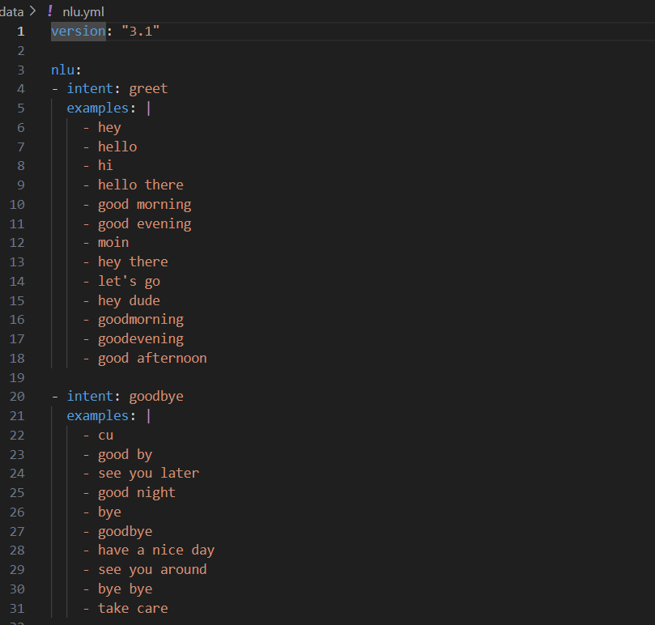

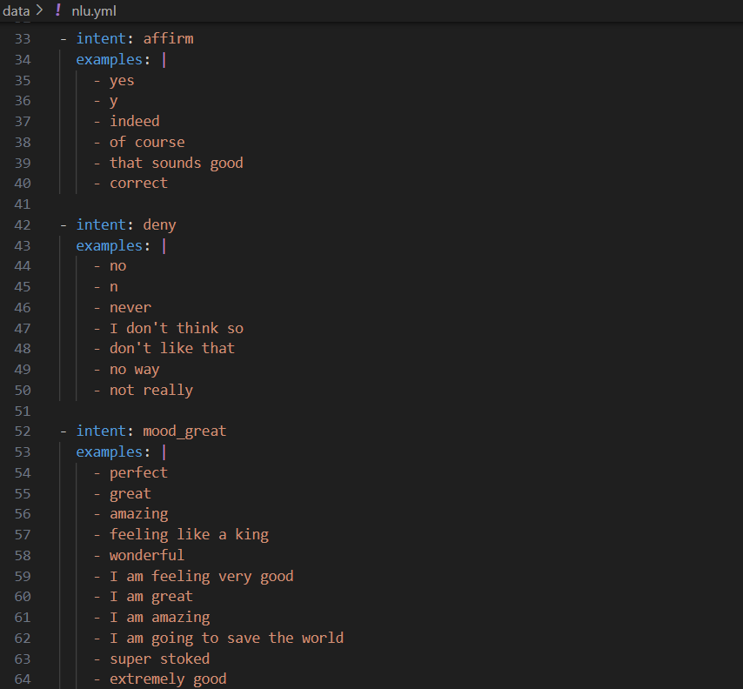

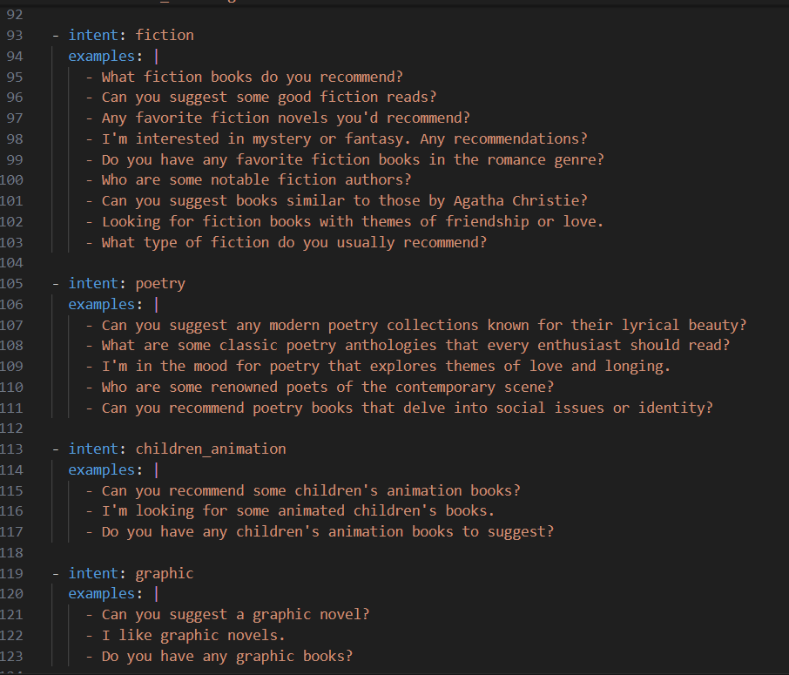

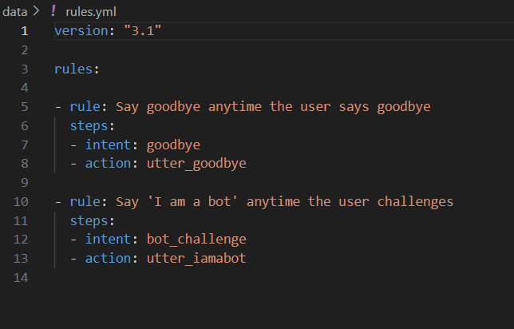

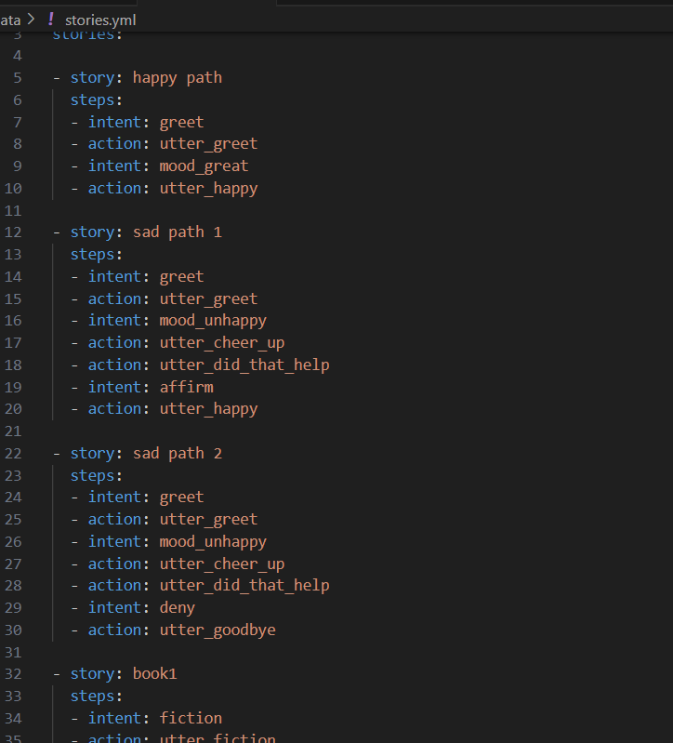

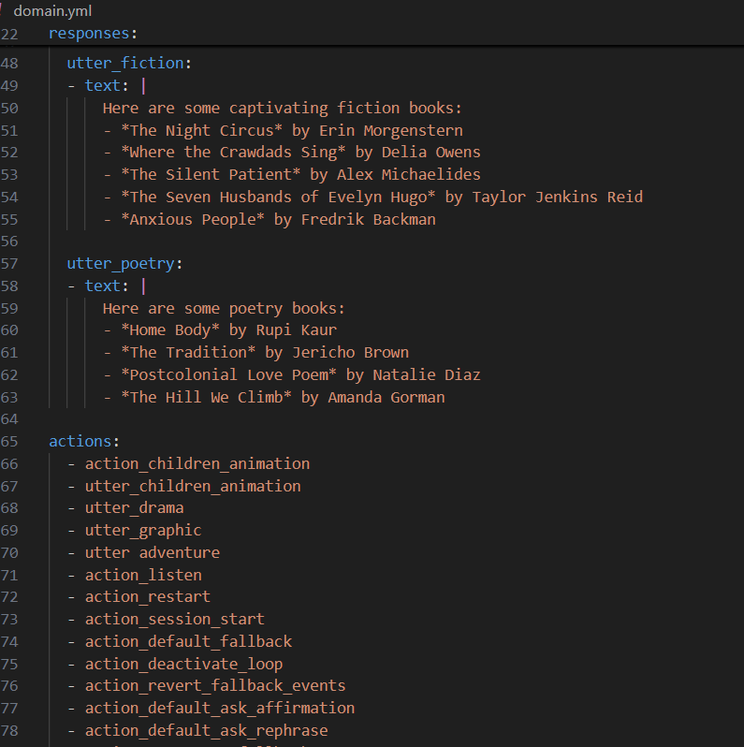

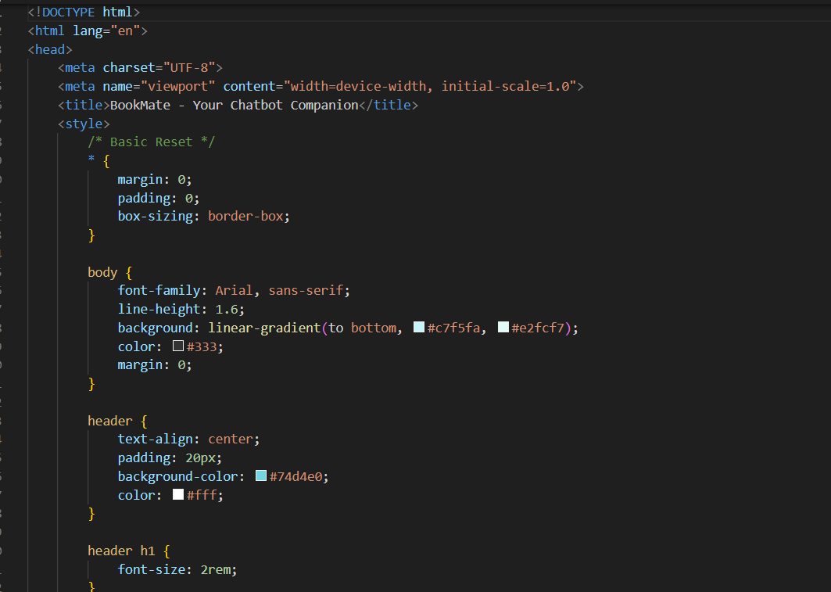

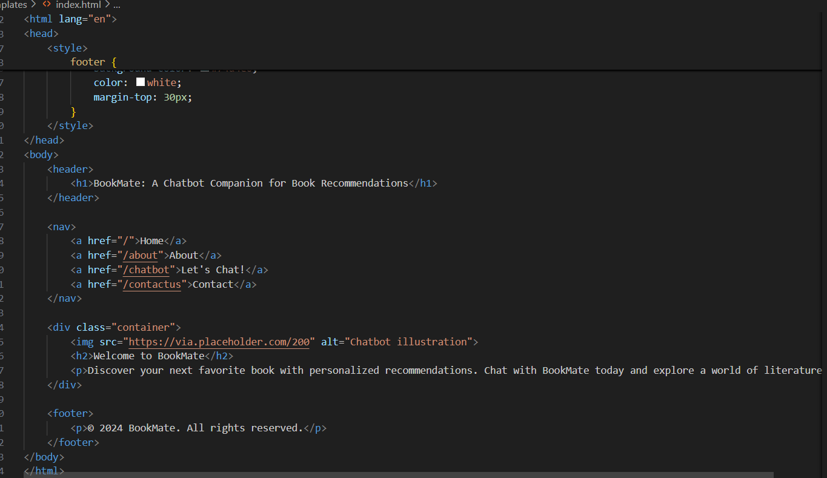

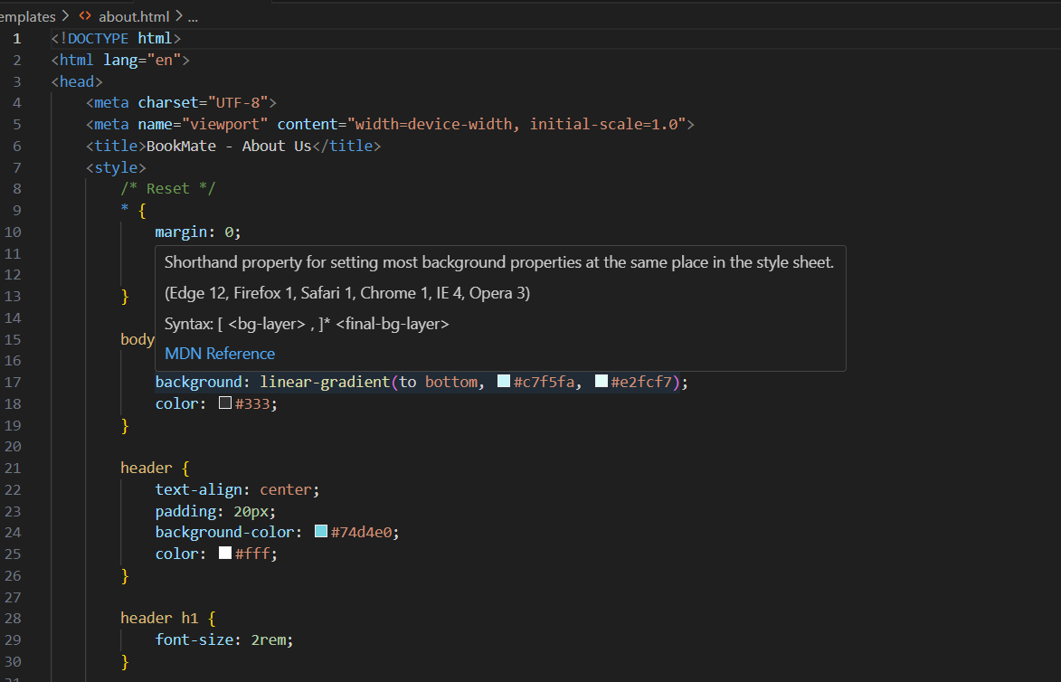

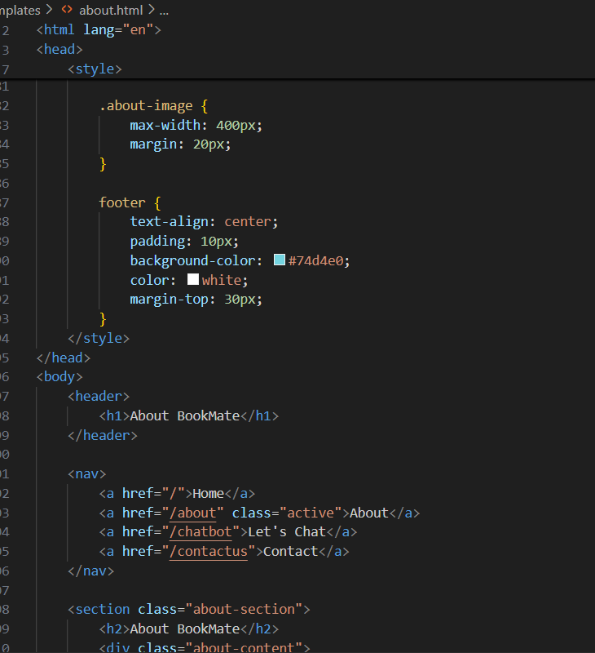

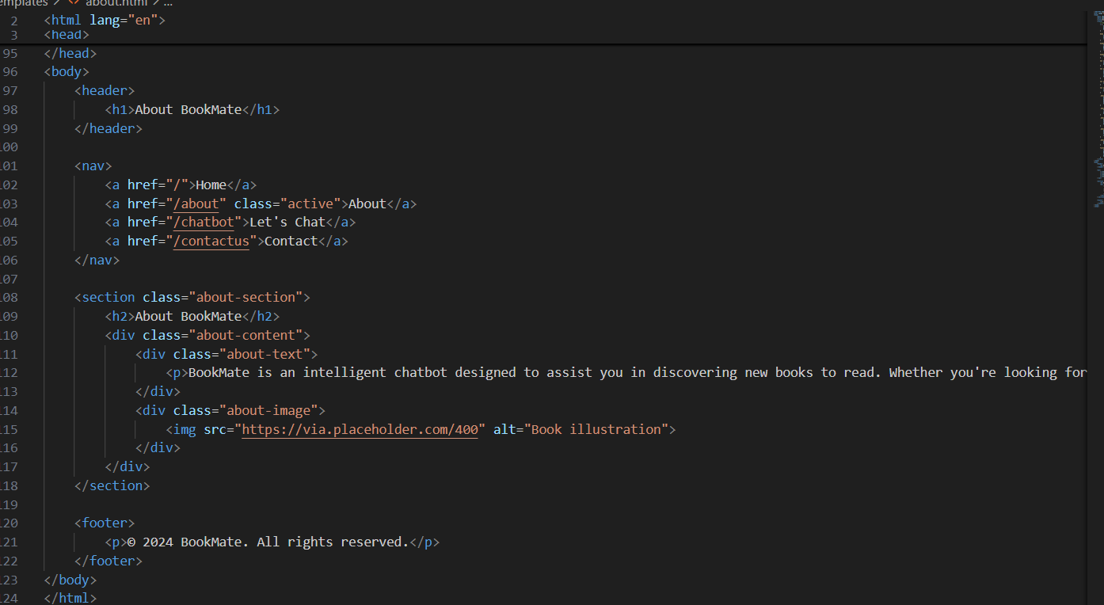

**10.2 Github & demo link:**